2220:
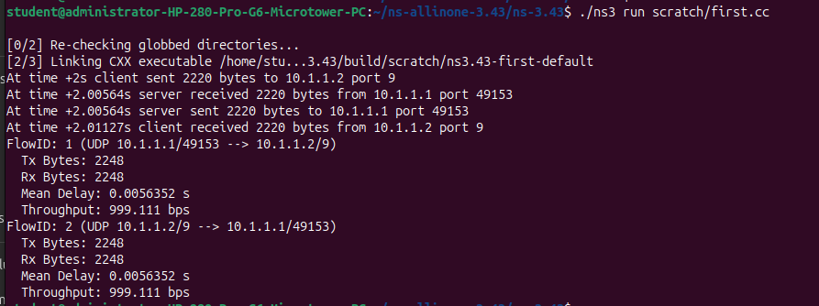
1101:
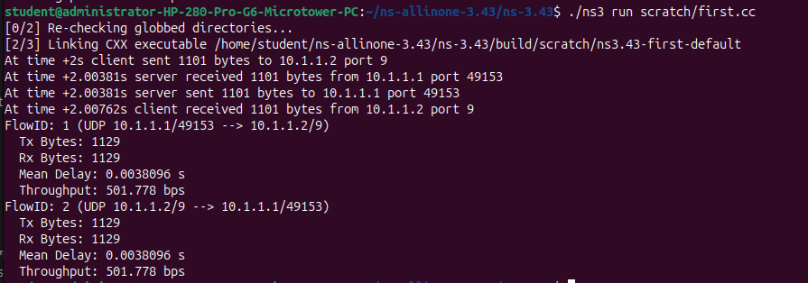
0222:
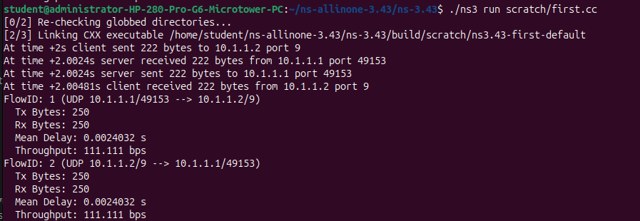
1011:
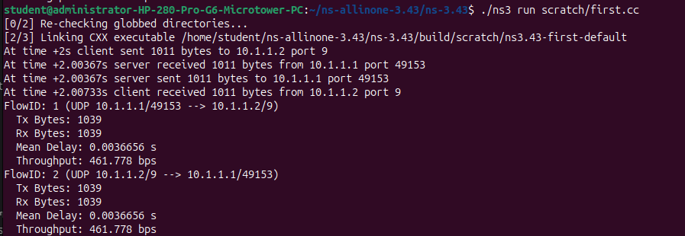
Graph:
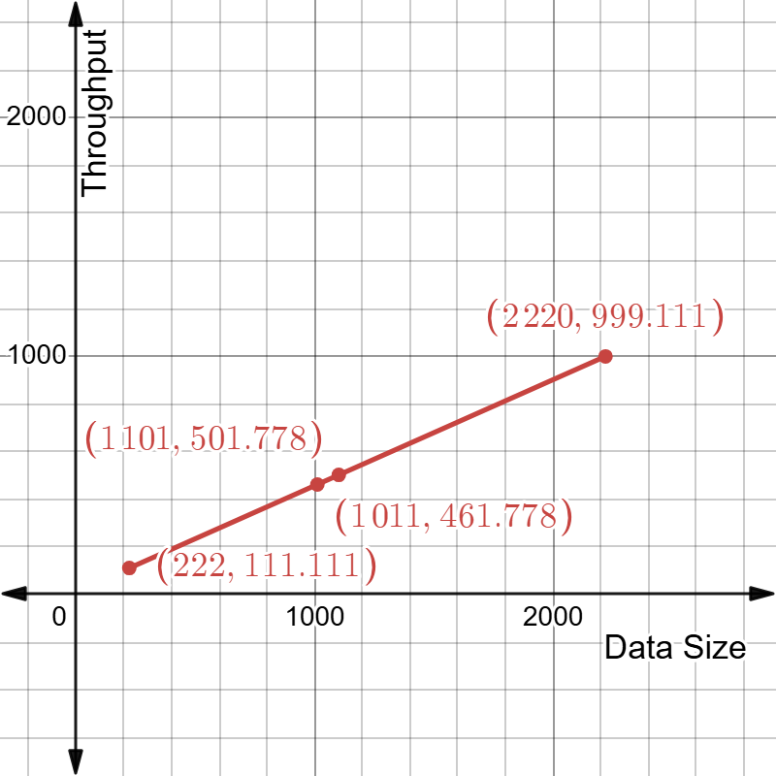
The graph shows a positive slope were as packet size increases , throughput increases linearly. This shows as the Data size increases the throughput in bits per second increases thus it is more efficient.

